Elastic Block Storage

Step 1: Create an Instance

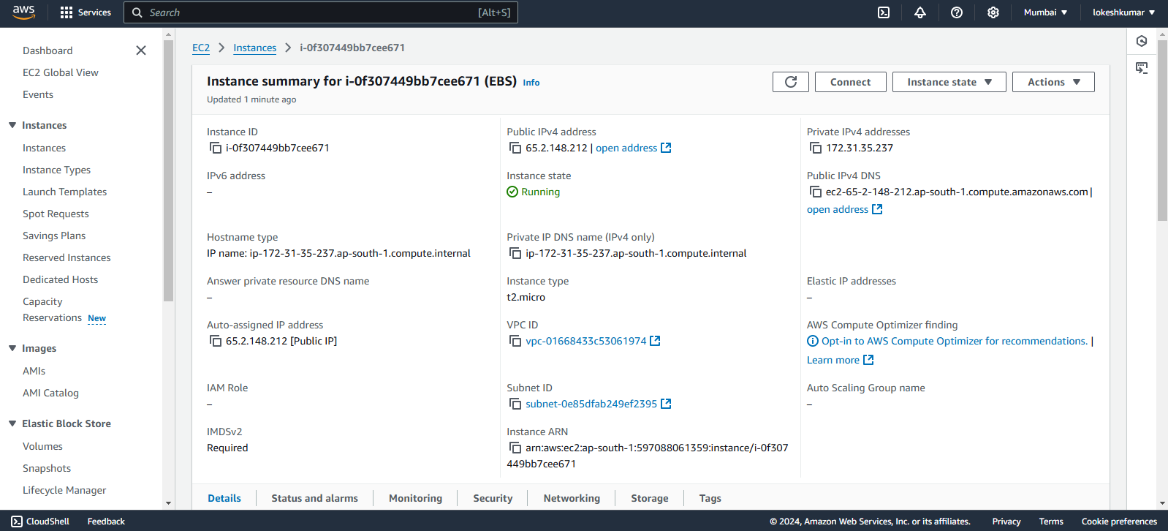

Step 2: Create a volume and attach volume to an EC2 Instance:

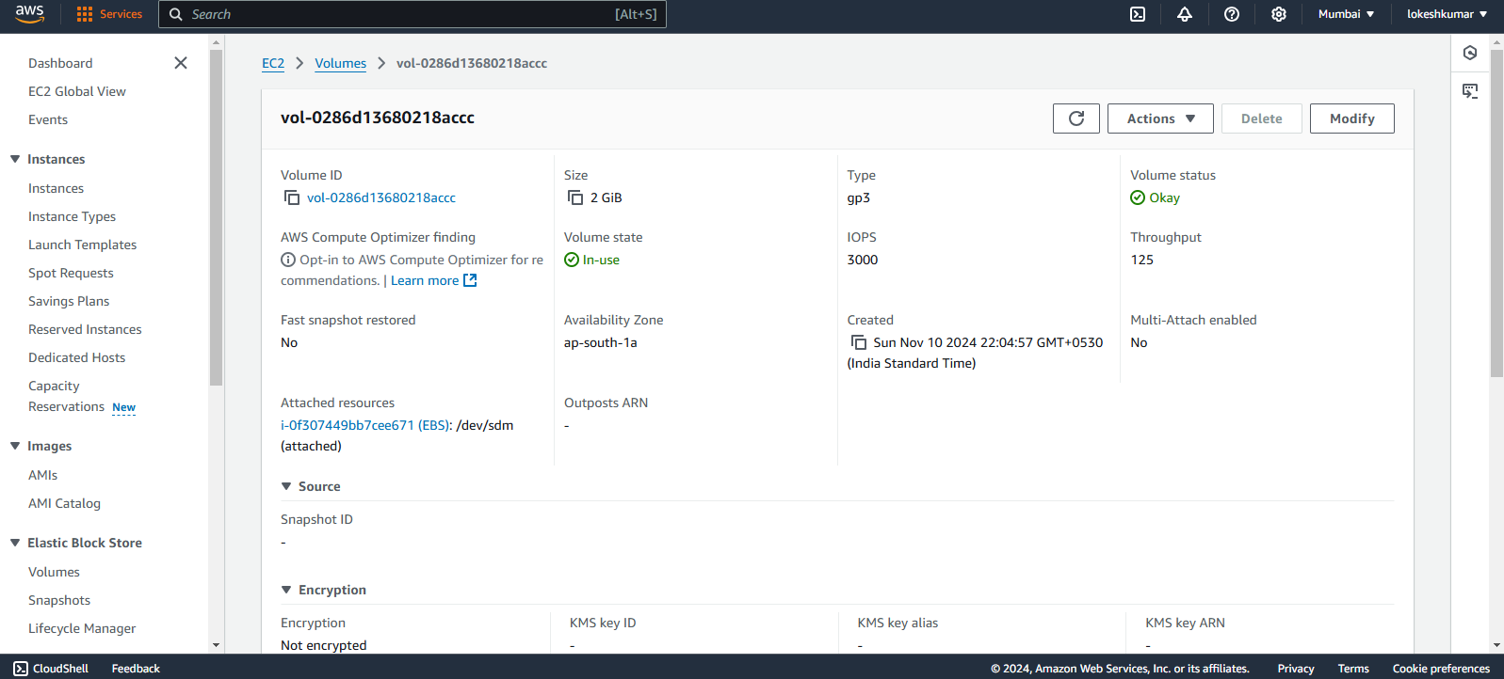

Step 3: Mount the volume in ec2 terminal

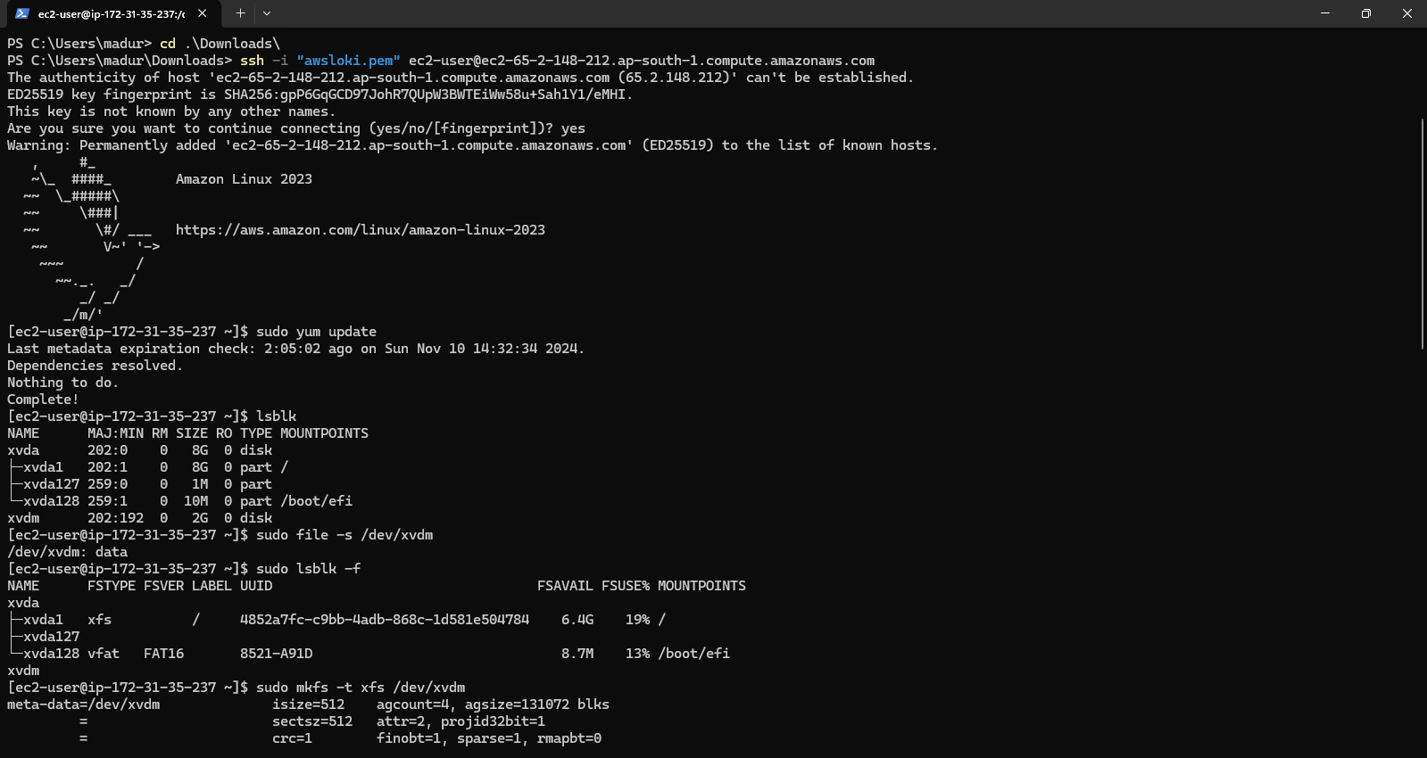

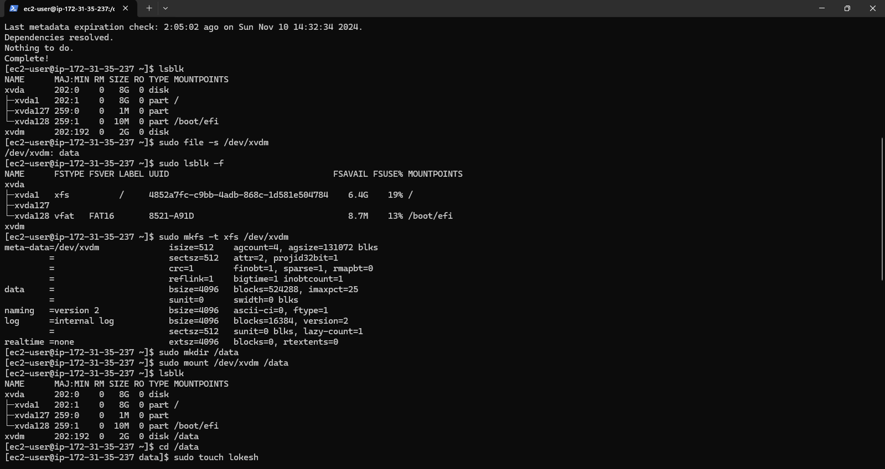

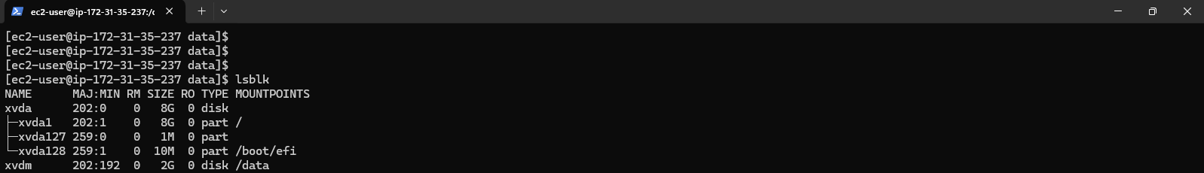

Step 4: Create a Snapshot

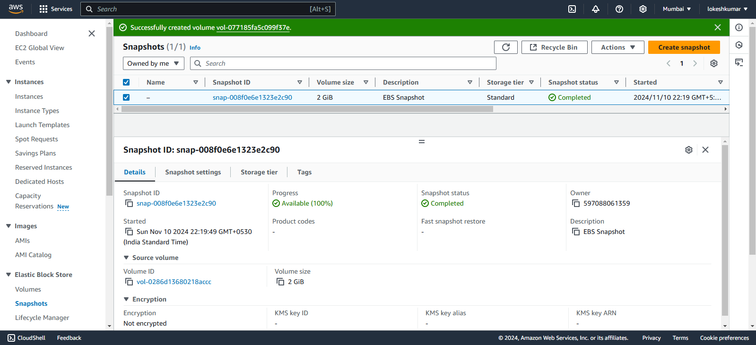

Step 5: actions > create a volume (delete the existing volume and from snapshot create a volume then attach to ec2 instance and mount them)

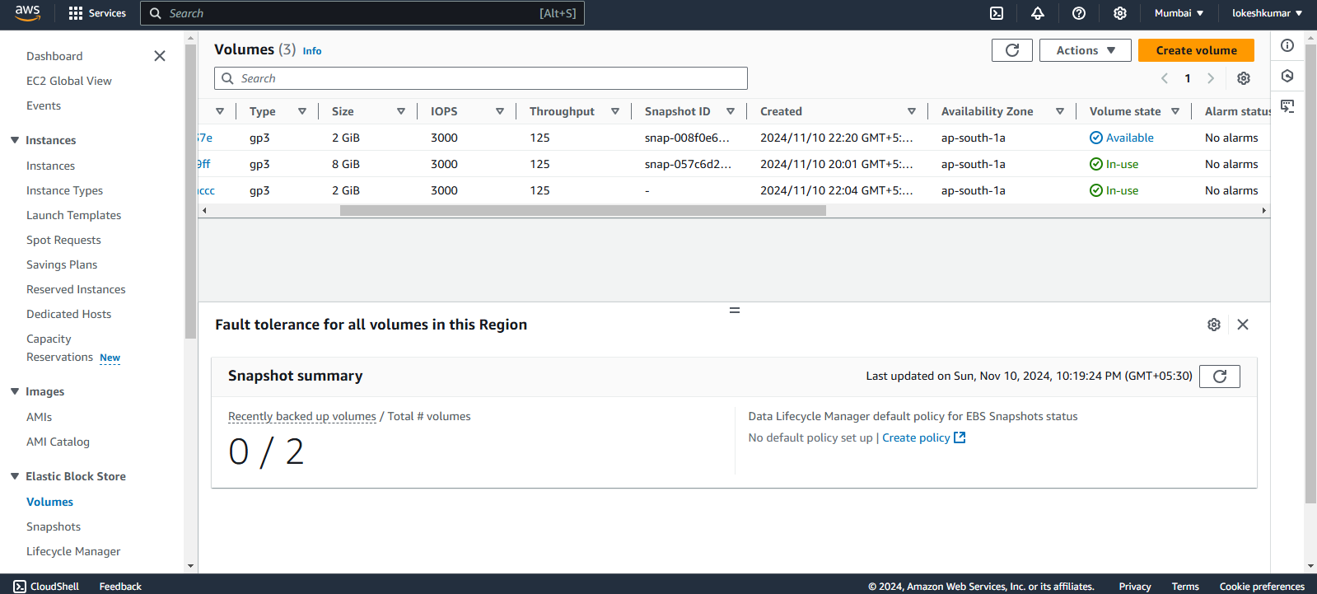

Step 6: mount the snapshot’s volume in an ec2 instance

